Planning Document

Missile Command

# Description

The game is played by moving a [crosshair](https://en.wikipedia.org/wiki/Crosshair) across the background and pressing one of three buttons to launch a counter-missile from the appropriate battery. Counter-missiles explode upon reaching the crosshair, leaving a fireball that persists for several seconds and destroys any enemy missiles that enter it. There are three batteries, each with ten missiles; a missile battery becomes useless when all its missiles are fired, or if the battery is destroyed by enemy fire.

There are six cities. The objective of the game is to protect the cities from the incoming enemy weapons.

The game contains a set number of incoming enemy weapons. Being struck by an enemy weapon results in destruction of the city or missile battery. The game ends when all enemy weaponry is destroyed or reaches its target. On conclusion of the game, the screen displays "The End".

https://en.wikipedia.org/wiki/Missile_Command

# Screen Shot

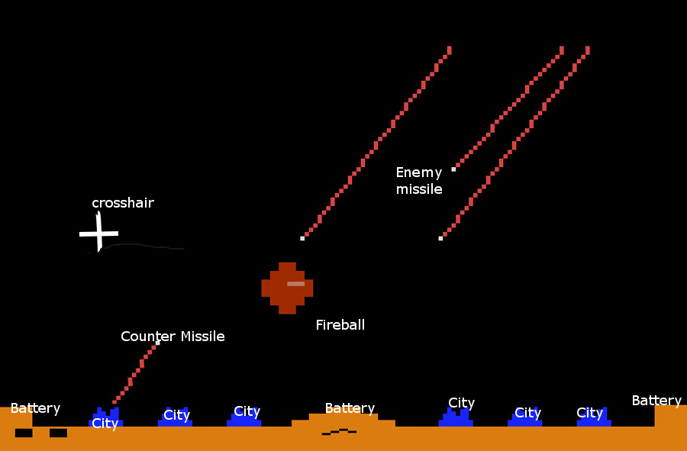

# Success Criteria

1. **Open a graphics window
2. **Display the crosshair
3. **Display the cities
4. **Display the batteries
5. **Launch missiles when keys are pressed (if battery has amo)
6. **Make missiles explode (fireballs) when they reach the crosshair
7. **Drop the enemy missiles
8. **Make enemy missiles disappear when they hit a fireball
9. **Make enemy missiles damage battery and city
10. **End game when cities are destroyed or no more enemy missiles

# Class Diagram

[Game|crosshair;background;listOfMissiles;batterys;listOfFireballs;cities|main();paint();run()]

[Location|x;y]

[Crosshair|location]

[Background|image]

[Missile|location;destination|update()]

[CounterMissile||makeFireBall(listOfFireballs)]

[EnemyMissile||testForHit(battery);testForHit(fireball);testForHit(city)]

[Battery|location;numMissilesLeft|fireMissile()]

[Fireball|location;timeLeft|update()]

[City|location]

[Missile]->[CounterMissile]

[Missile]->[EnemyMissile]

[Game]-.->[Crosshair]

[Game]-.->[Background]

[Game]-.->[Missile]

[Game]-.->[Battery]

[Game]-.->[Fireball]

[Game]-.->[City]

[Crosshair]-.->[Location]

[Missile]-.->[Location]

[Battery]-.->[Location]

[Fireball]-.->[Location]

[City]-.->[Location]

Game (crosshair, background, ListOfMissiles, Battery 1 2 3, ListOfFireballs, Cities 1 2 3 4 5 6)

Main method

Paint

run

Location (x,y)

Crosshair (location)

Follow the mouse()

Background (image)

Display on screen()

Missile (location,destination)

Update position()

Counter-missile : extends missile

Make fireball(listOfFireballs)

enemy -missile : extends missile

Test for hit with (battery, fireball, city)

Battery (location, numMissilesLeft)

Fire missile()

Fireball (location,timeLeft)

update()

Cities (location)

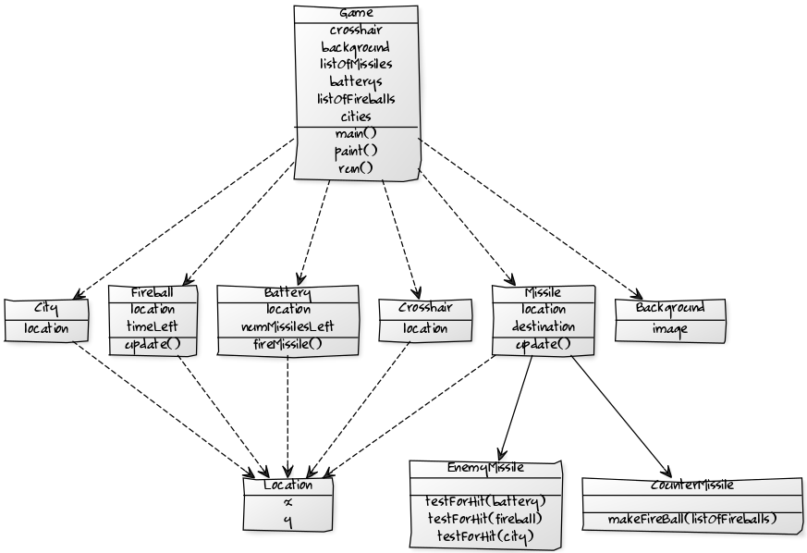

# Use Cases

|  |  |  |
| --- | --- | --- |
| Program State | Event | Program Response |
| Program is not yet running | The program is started | 6 cities, 3 batteries each with 15 missiles are displayed on the screen. Random enemy missiles begin to fall |
| Program is running | User moves the mouse | Crosshair moves accordingly |
| Program is running | User hits ‘a’ key | Missile launches from left battery with crosshair location as target. |
| Program is running | User hits ‘s’ key | Missile launches from middle battery with crosshair location as target. |
| Program is running | User hits ‘d’ key | Missile launches from right battery with crosshair location as target. |
| Program is running | Enemy missile reaches target city or battery. | Target is destroyed. |
| Program is running | Player missile reaches target | Turns into fireball |
| Program is running | Enemy missile hits fireball | Missile is destroyed |
| Program is running | User tries to launch missile from depeated/destroyed battery | No missile is launched |
| Program is running | All cities are destroyed | Game Over appears |